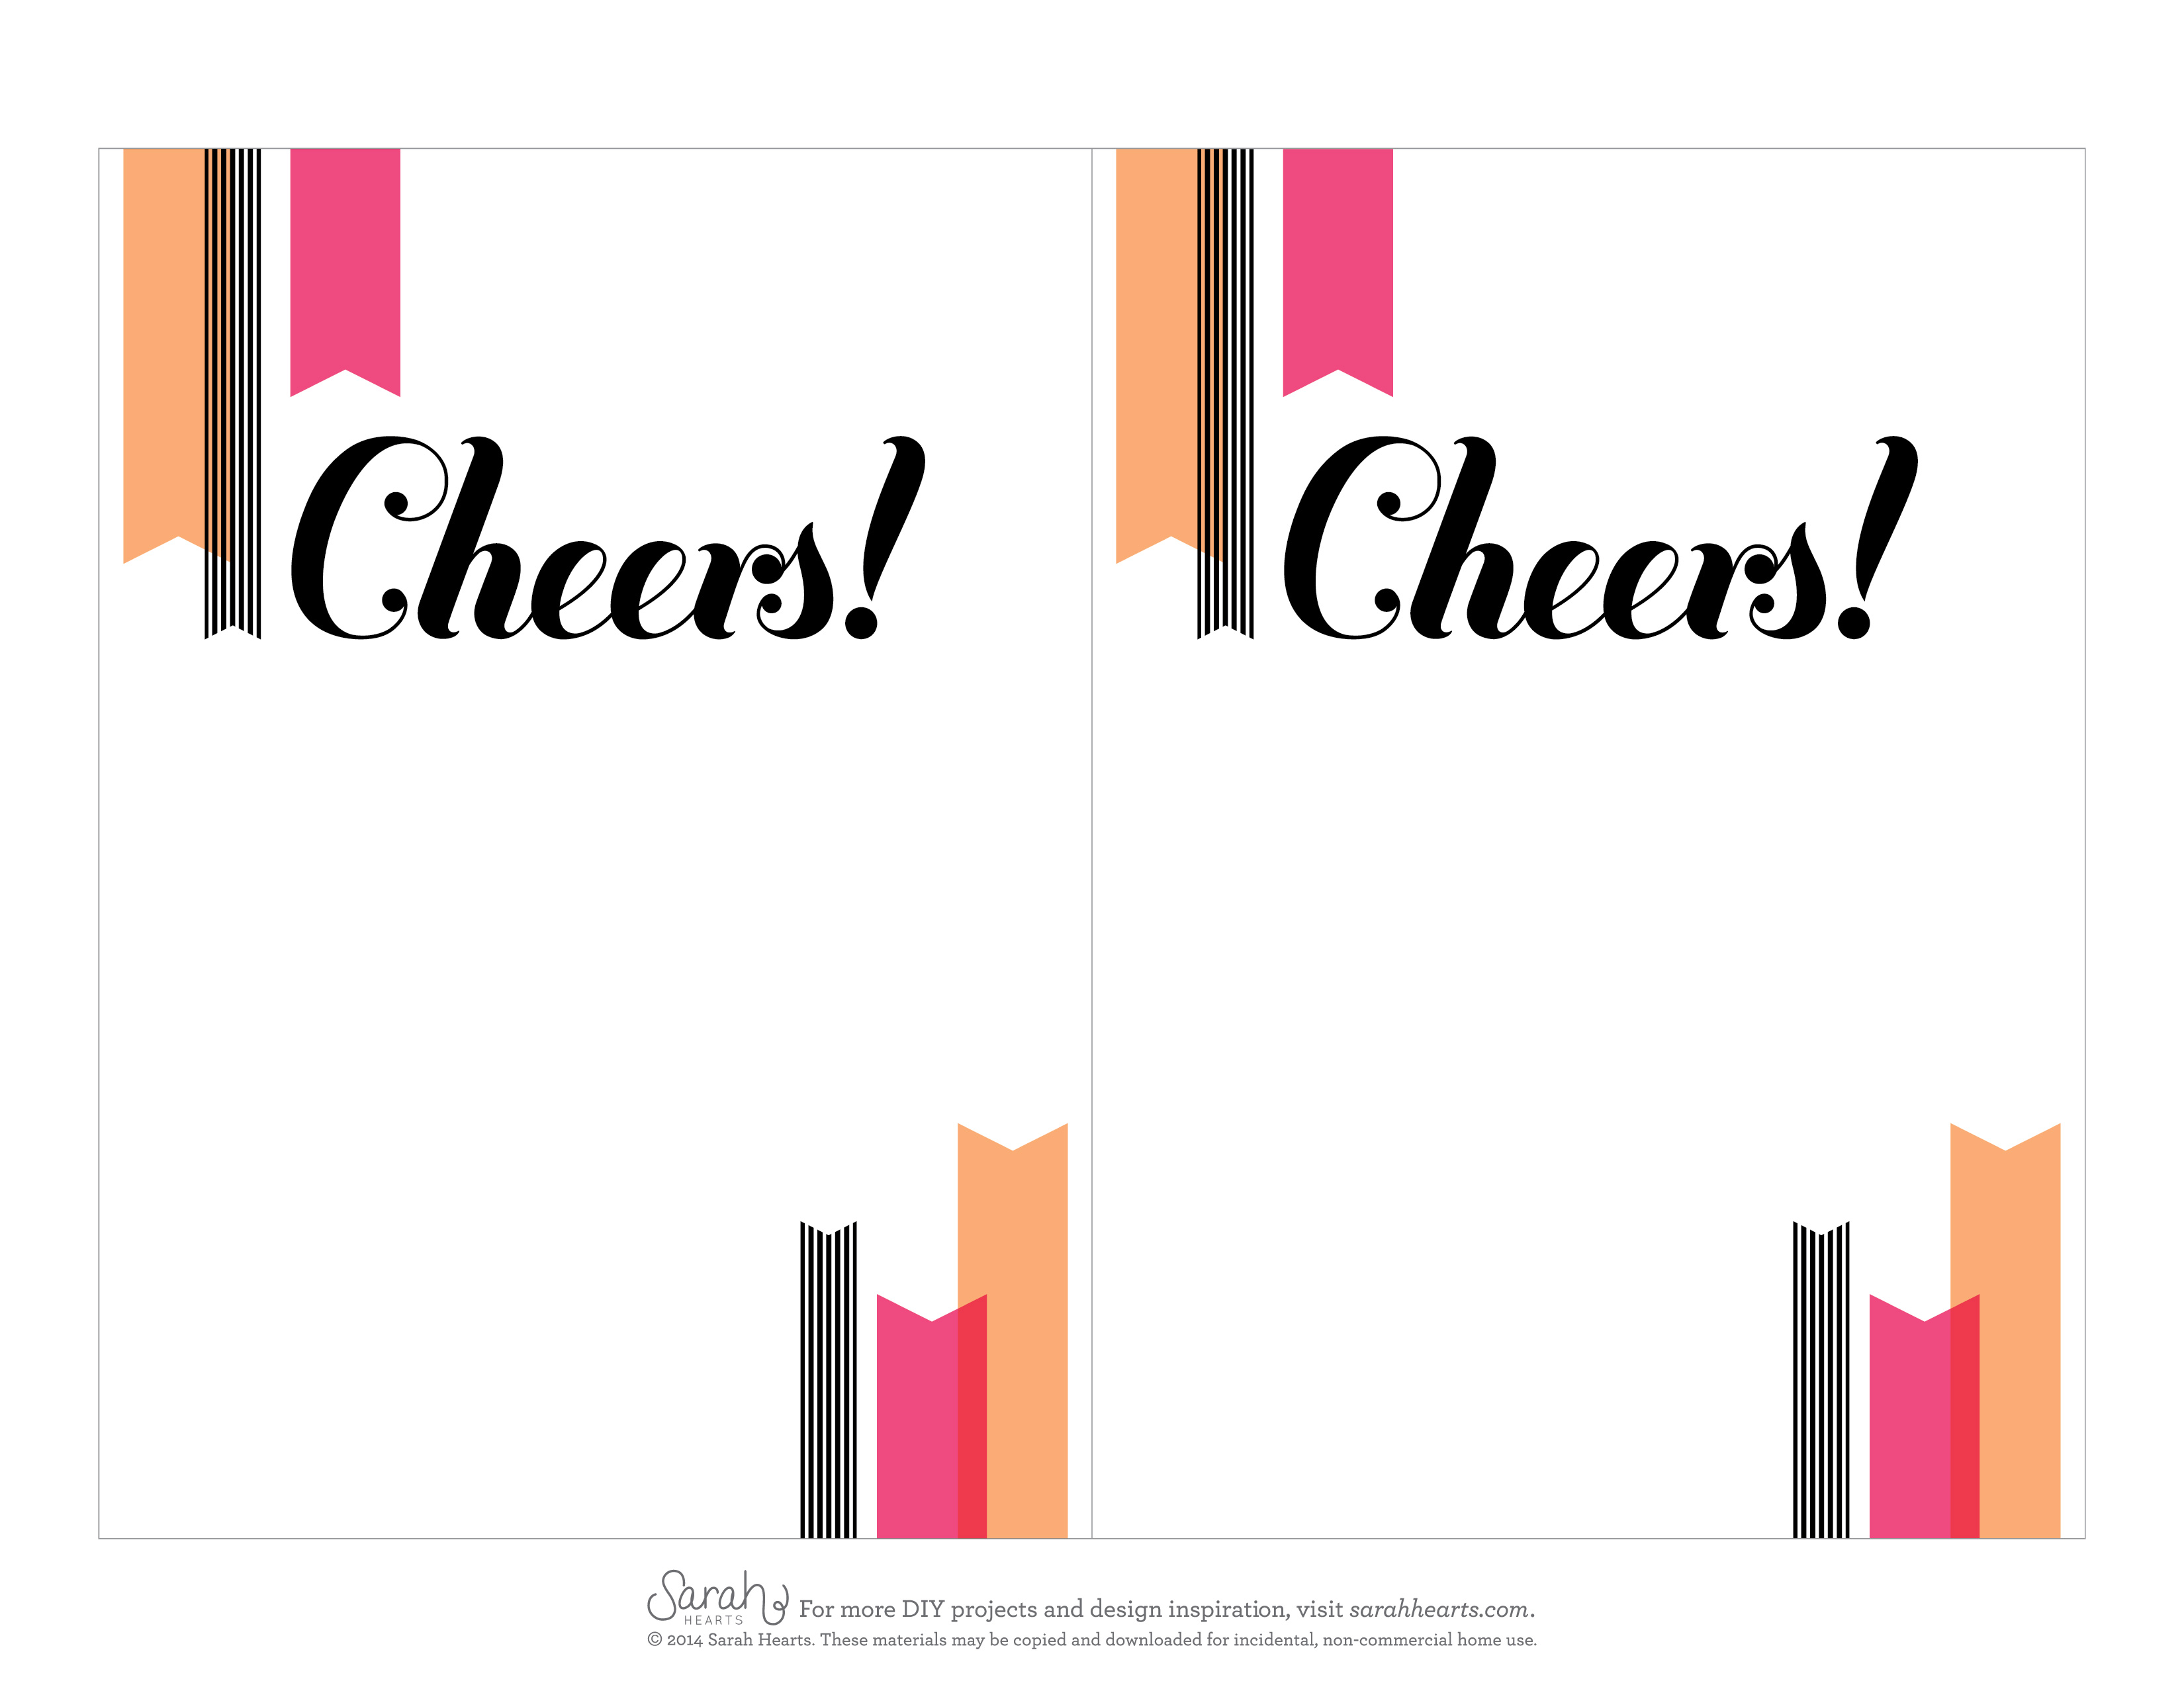

let’s celebrate summer over

snacks and sips

saturday, july twelfth, 2014

at the home of Katie smith

1020 Washington drive, orlando

rsvp to Katie 407.201.3542

let’s celebrate summer over

snacks and sips

saturday, july twelfth, 2014

at the home of Katie smith

1020 Washington drive, orlando

rsvp to Katie 407.201.3542