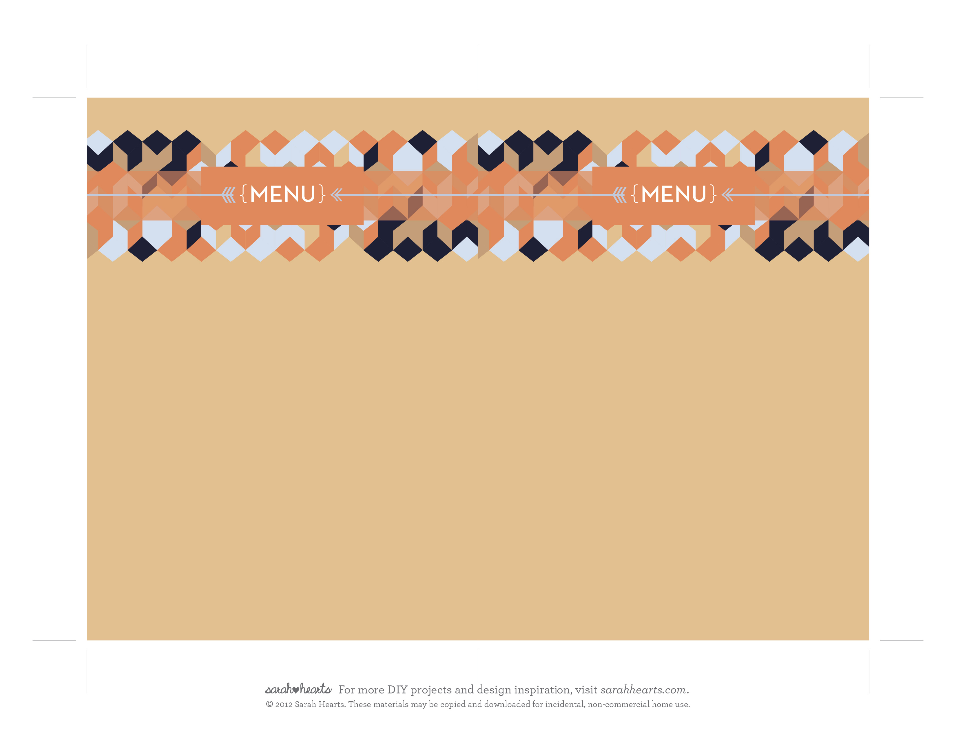
starters
Almond Dates Wrapped with Bacon
Chutney Baked Brie with Crackers

dinner
Turkey with Dipping Sauces
Green Beans with Blue Cheese Balsamic Dressing
Orange Walnut Salad with Poppy Seed Vinaigrette
Maple Sweet Potato Casserole
Core Bread Soufflé

Dessert
Chocolate Chess Pie
Pumpkin Crème Brûlée
starters
Almond Dates Wrapped with Bacon
Chutney Baked Brie with Crackers

dinner
Turkey with Dipping Sauces
Green Beans with Blue Cheese Balsamic Dressing
Orange Walnut Salad with Poppy Seed Vinaigrette
Maple Sweet Potato Casserole
Core Bread Soufflé

Dessert
Chocolate Chess Pie
Pumpkin Crème Brûléev

